**Abiodun Oke** DBS201 ASSIGNMENT-2 Worth 6%

DUE DATE: Nothing will be accepted after this date. It will get a zero.

Submit your document **BEFORE MIDNIGHT on Friday, March 31st**

**PLAGIARISM**   
When you submit an assignment, you are saying that the submission is your own work and as such you wish to be given credit for the work.

Q-1For the following user view, create a set of normalized 3NF tables. Be sure to show each step (UNF, 1NF, 2NF, 3NF) and mark Primary and Foreign Keys.

Q-2 Produce an ER Diagram that models your finished design

Project Management Report

Project code: PC010

Project Title: Pension System

Project Manager: M Philips Project Budget: $24500

Employee No Employee Name Department No Department Name Hourly Rate

S10001 A Smith L004 IT $22.00

S10030 L Jones L023 Pension $18.00

Total Staff on Project: 4 Average Hourly Rate: $42.00

Use following data set for the user view:

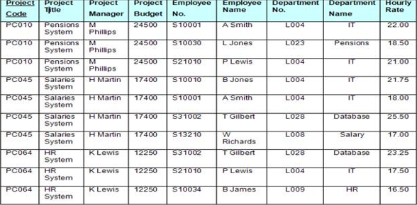

UNF: PROJREPORT [**Project_Code**(Project_Title, Project_Manager, Project_Budget, Employee_No, Employee_Name, Department_No, Department_Name, Hourly_Rate)]

1NF: PROJREPORT [**Project_Code**, **Department_No**, Project_Title, Project_Manager, Project_Budget, Employee_No, Employee_Name, Department_Name, Hourly_Rate]

2NF: PROJREPORT [**Project_Code**, **Department_No**]

DEPARTMENT [**Department_No**, Department_Name, Employee_No, Employee_Name, Hourly_Rate]

PROJECT [**Project_Code**, Project_Title, Project_Manager, Project_Budget]

3NF: PROJREPORT [**Project_Code**, **Department_No**]

DEPARTMENT [**Department_No**, Department_Name, Employee_No]

EMPLOYEE [**Employee_No**, Employee_Name, Hourly_Rate]

PROJECT [**Project_Code**, Project_Title, Project_Manager, Project_Budget]

ER Diagram:

|  |
| --- |
| **PROJECT**  **PK** Project_code,  Project_Title,  Project_Manager,  Project_Budget |

|  |
| --- |
| **PROJECTREPOET**  **PK** Project_code  FK1 Department_No |

M 1

1

M

|  |
| --- |
| **EMPLOYEE**  Employee_No  Department_Name  Hourly_Rate |

|  |
| --- |
| **DEPARTMENT**  PK Department_No  Department_Name  FK1 Employee_No |

M N